**Access problem**

1. Final diagram at Pentaho Data Integration

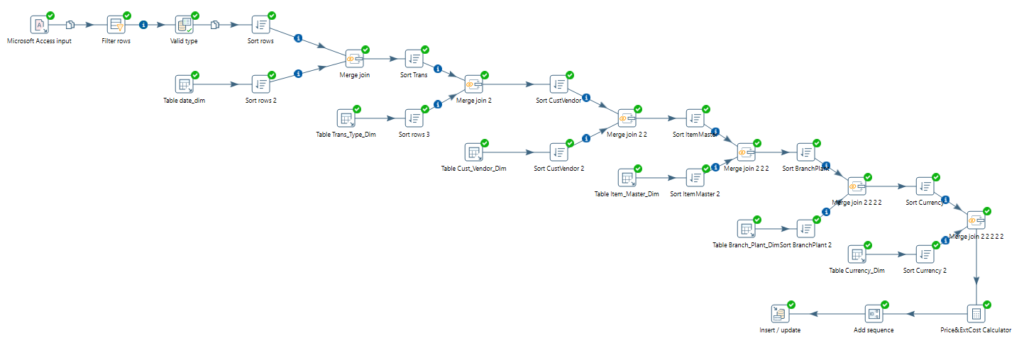

1. Inventory_Fact table (screenshot from pg_admin)

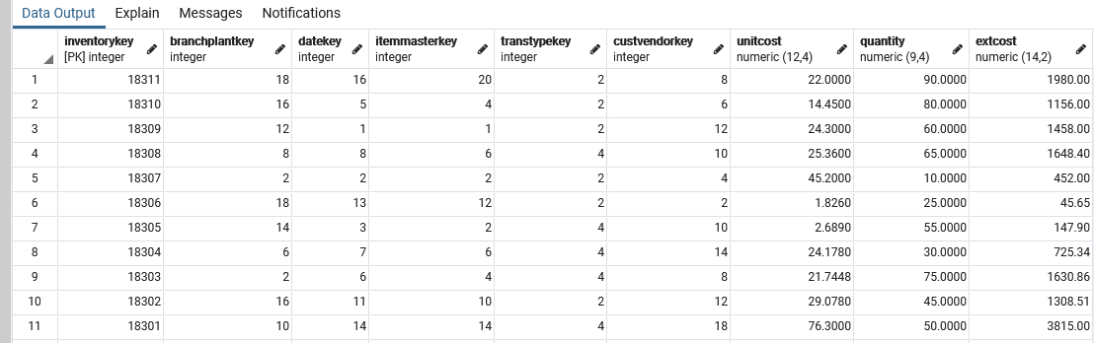

**Steps of execution**

1. Access Input

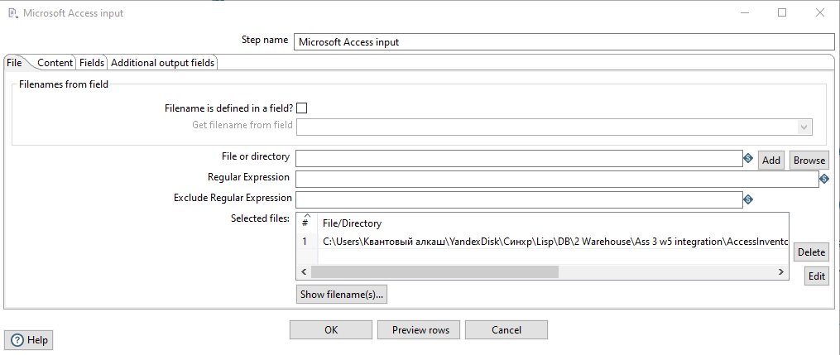

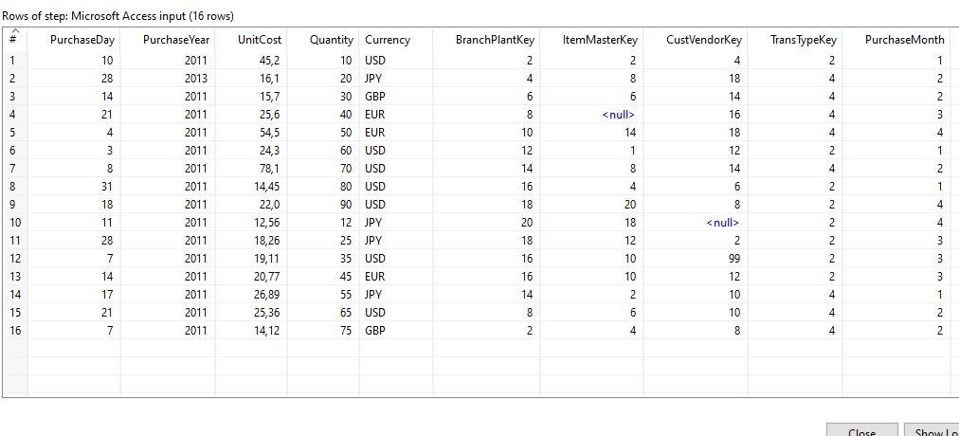

1. Filter rows

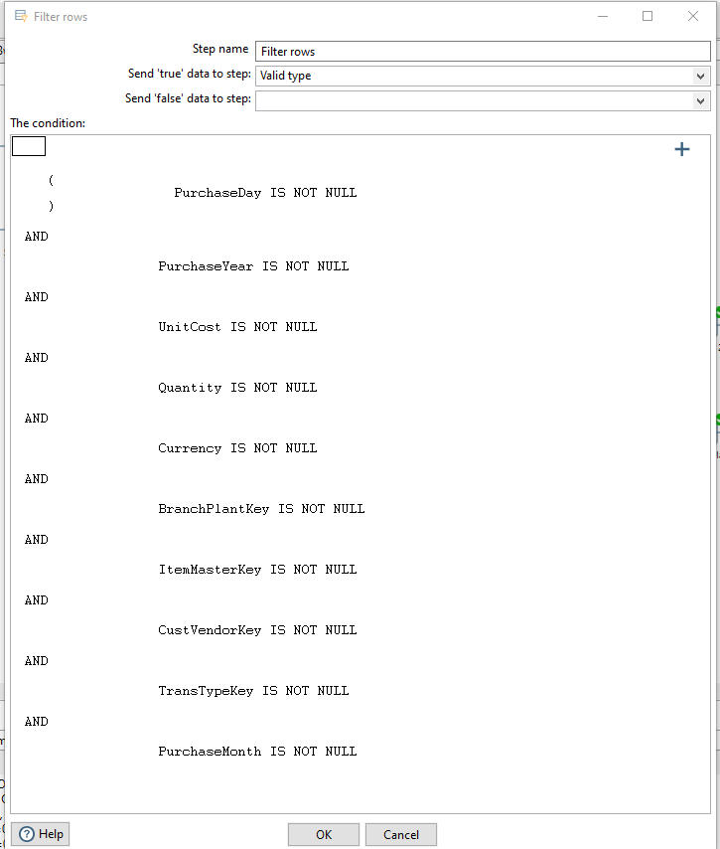

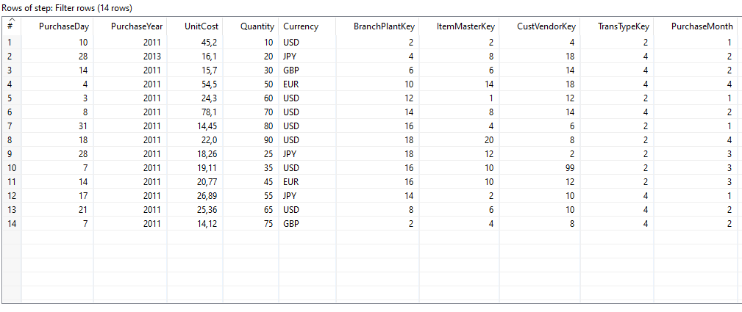

1. Data validation (checking date format)

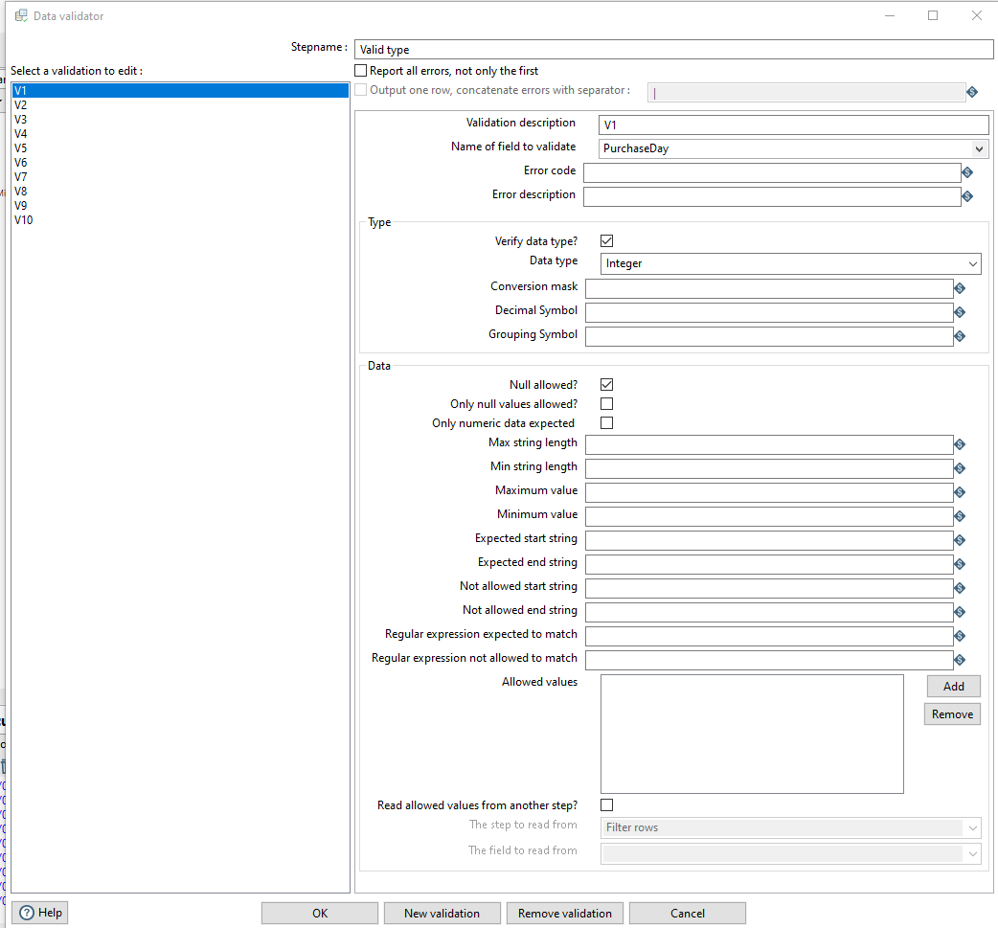

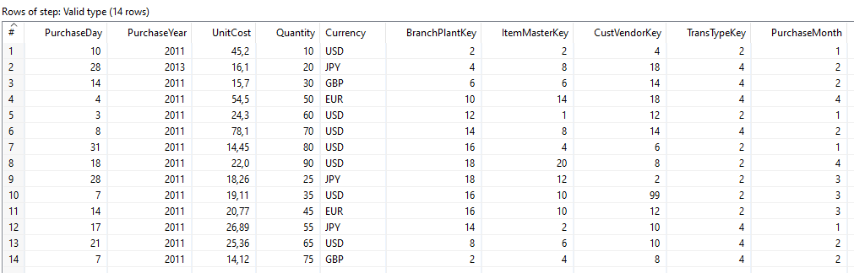

1. Sort by date

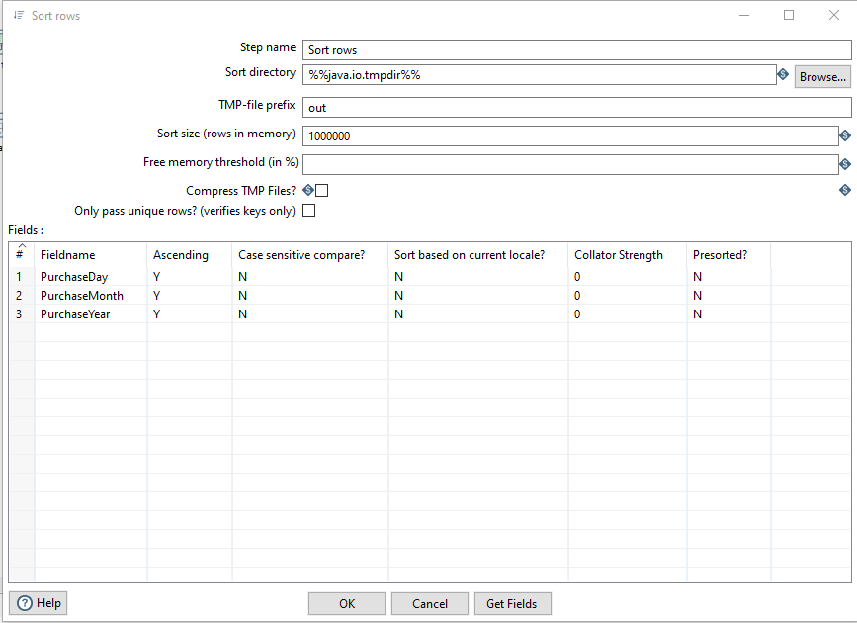

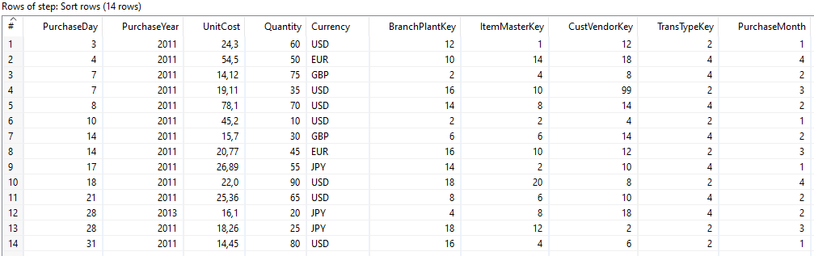

1. Database date_dim input

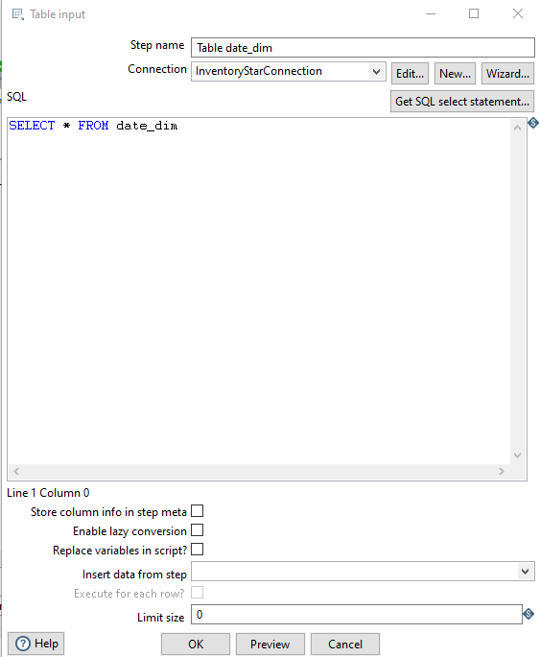

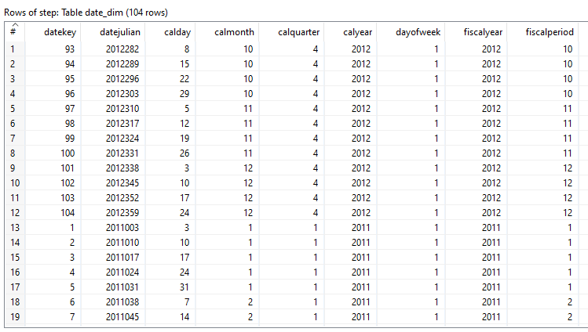

1. Sorting date_dim by date

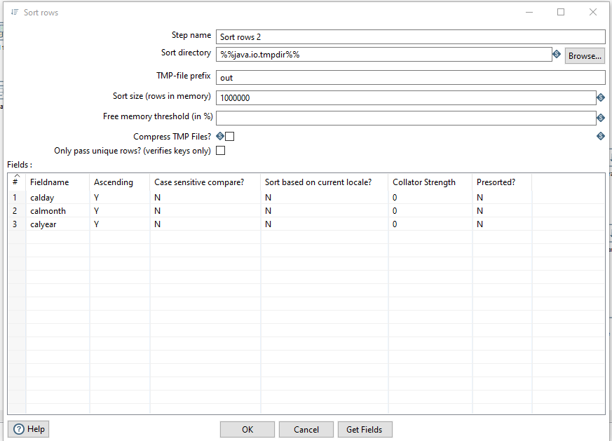

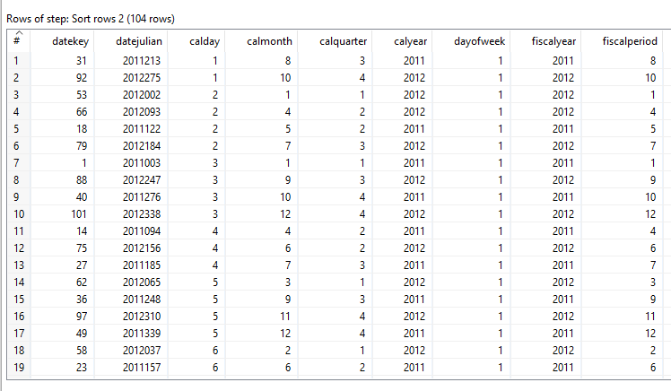

1. Merge join

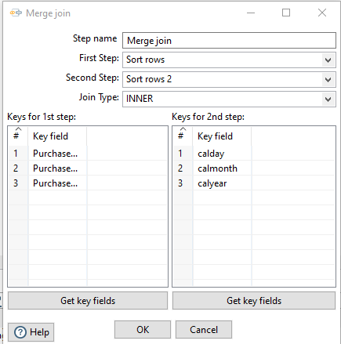

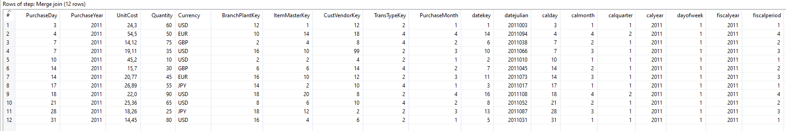

Further sorting and join operations are similar, so windows with adjustments are omitted

1. Trans_type join

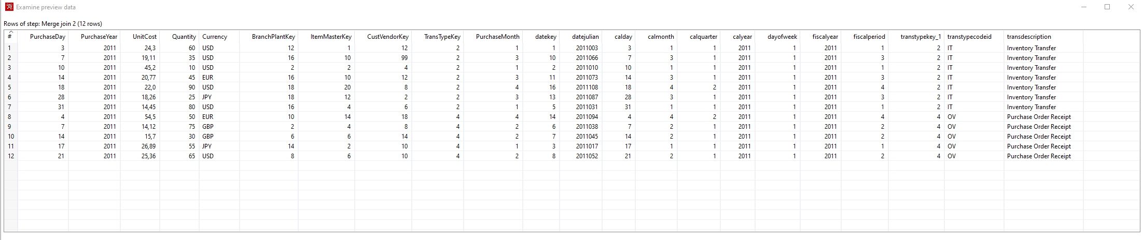

1. Cust_vendor join

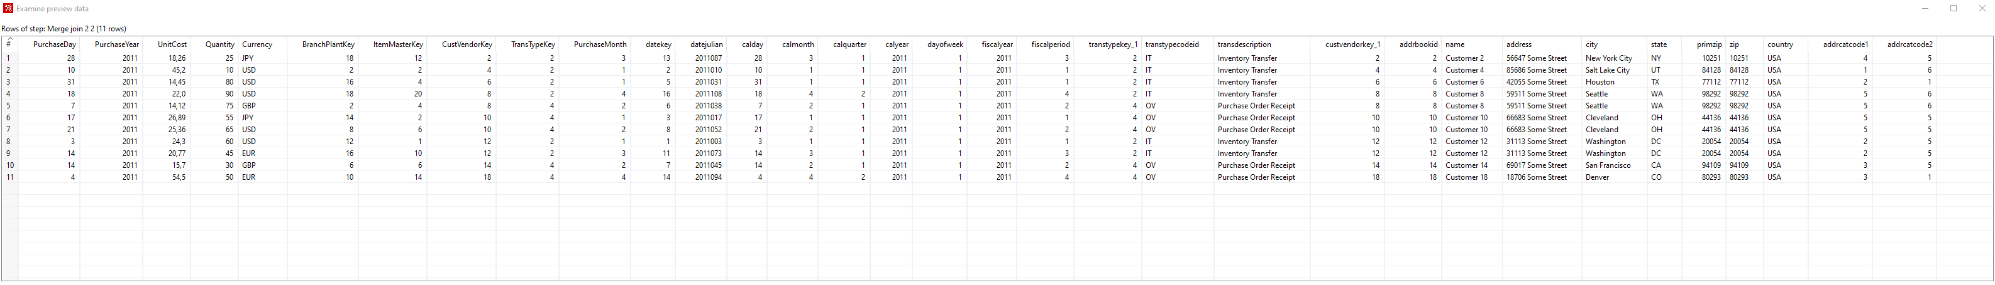

1. Result tables of Item_master join, Branch_plant join, Currensy join are too big.

Step Metrics:

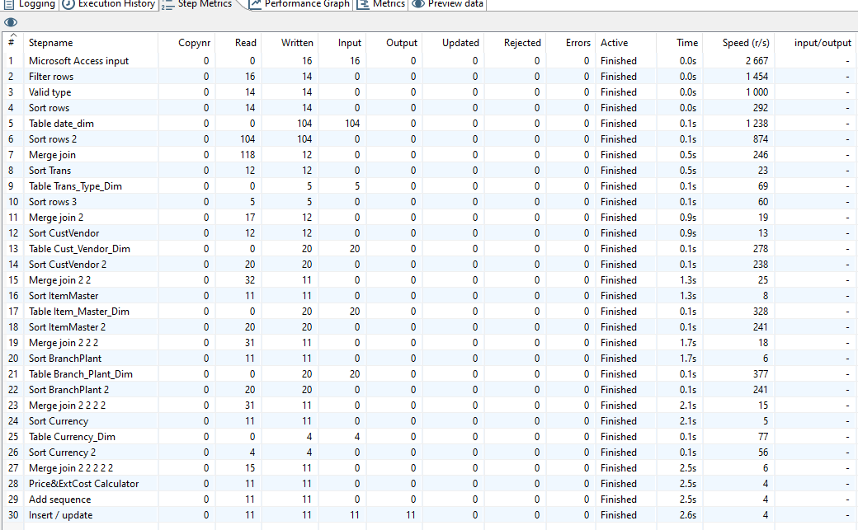

1. Calculator adjustments

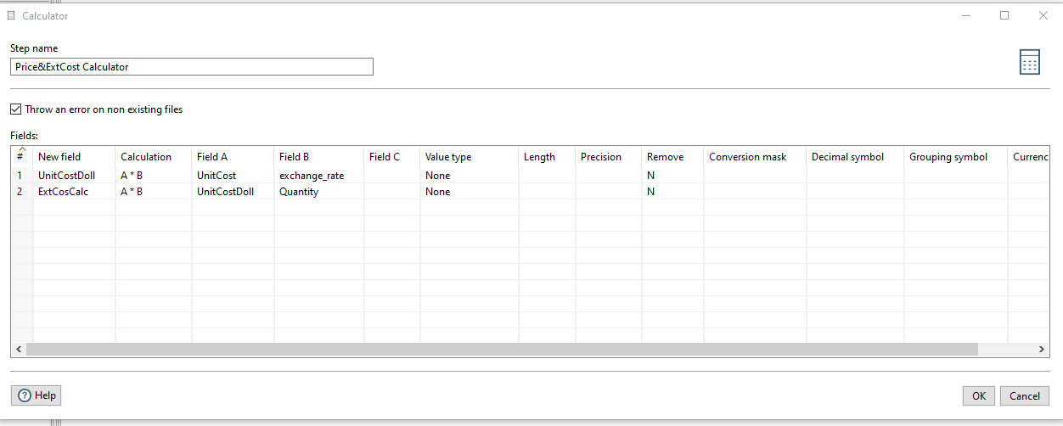

1. Sequence adjustments

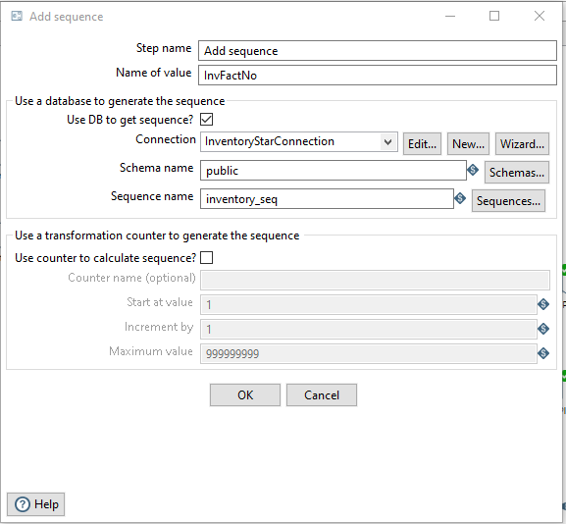

1. Insert / update adjustments

